***User and Group Management Screenshots***

***High Level Commands***

***User Addition***

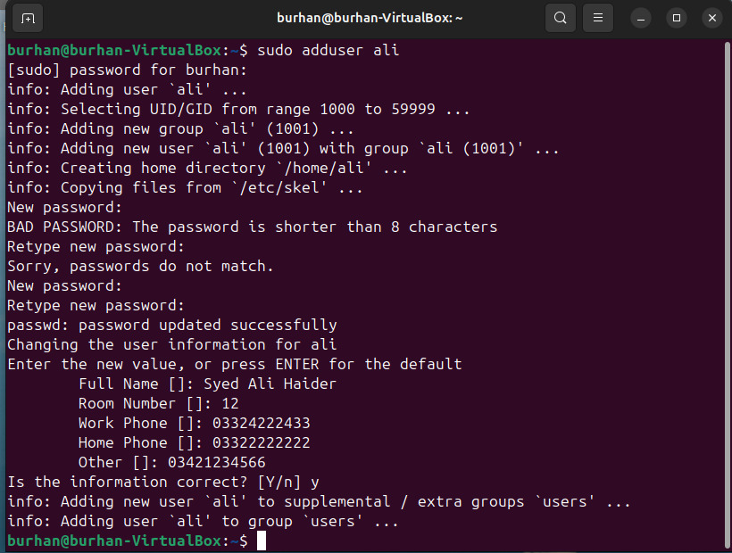

***Group Addition***

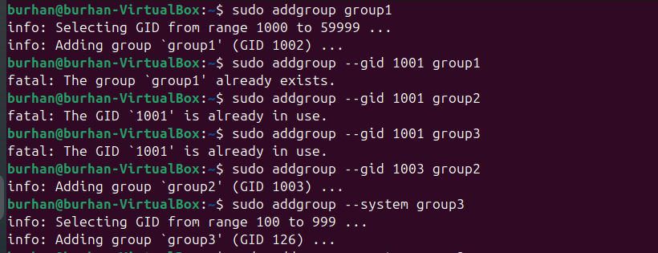

***Group Deletion***

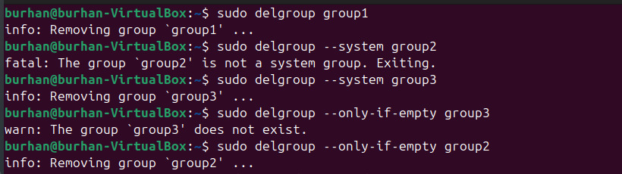***Adding user in Group***



***User Modification***

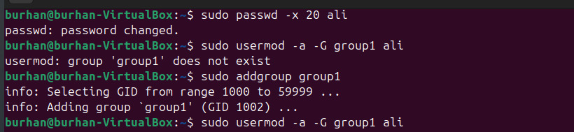

***User Deletion***

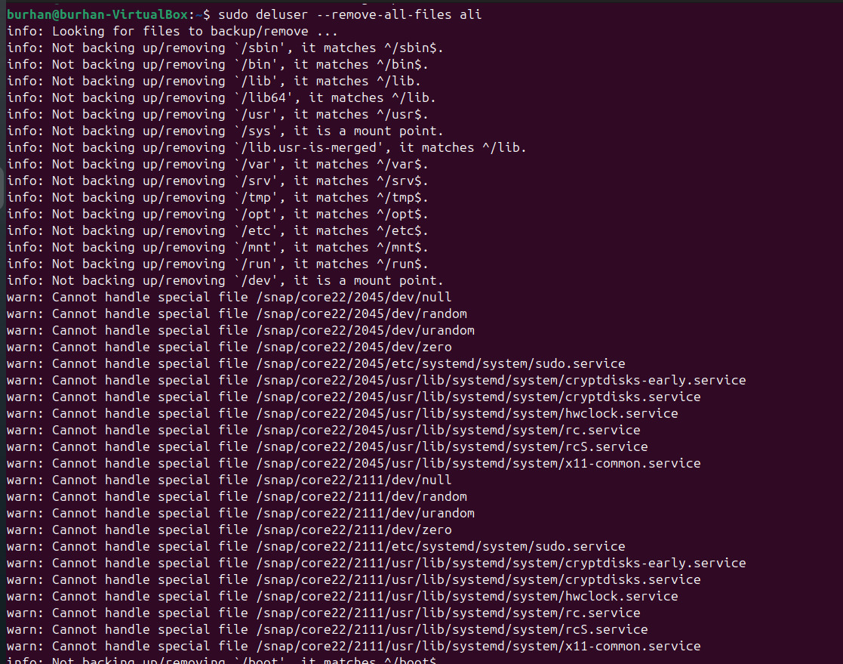

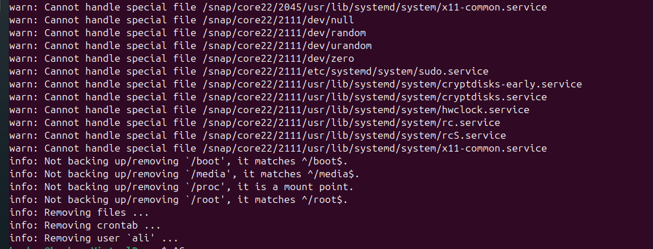***Low Level Commands***

